MATLAB programs from chapter 4

Program 1: A MATLAB Program to find LPC and refection coefficients using Levinson Durbin algorithm is given below.

%program to calculate lpc coefficients, reflection coefficients using
%levinson Durbin algorithm.

clear all;
fp=fopen('watermark.wav');
fseek(fp,224000,-1);
x=fread(fp,128);
subplot(2,1,1);plot(x);title('plot of voiced part of a signal');
xlabel('sample no.');ylabel('amplitude');
x=x-128;

sum=0;
i=1;
for k=1:128,
sum=sum+x(k)*x(k);
end
r(1)=1;

for i=2:12,% a loop to find time domain autocorrelation, r is the array of autocorrelation coefficients
sum1=0;
sum2=0;
for k=1:128-i,
sum1=sum1+x(k)*x(k+i);
sum2=sum2+x(k+i)*x(k+i);

end
r(i)=sum1/sqrt(sum*sum+sum2*sum2);

end
%Lvinson Durbin recursion
ap = 0;
g = [];
aj(1) = 1;
ej = r(1);
e = [ej];
for j=1:11,
aj1 = zeros(j+1, 1);
aj1(1) = 1;
rcj = r(j+1);
for i=2:j,
rcj = rcj + aj(i)*r(j-i+2);
end
rccj1 = -rcj/ej;
g = [g ; rccj1];
for i=2:j,
aj1(i) = aj(i)+rccj1*(aj(j-i+2)');
end
aj1(j+1) = rccj1;
ej1 = ej*(1-abs(rccj1)^2);
e = [e ; ej1];
aj = aj1;
ap = aj1;
ej = ej1;
end
b0 = sqrt(ej1);
subplot(2,1,2);plot(ap);title('plot of predictor coefficient for a signal');
xlabel('coefficient number');ylabel('value of coefficient');
figure;
subplot(2,1,1);plot(g);title('plot of reflection coefficient');
xlabel('coefficient no.');ylabel('value of coefficient');
subplot(2,1,2);plot(e);title('plot of squared error');
xlabel('iteration no.');ylabel('amplitude of error');

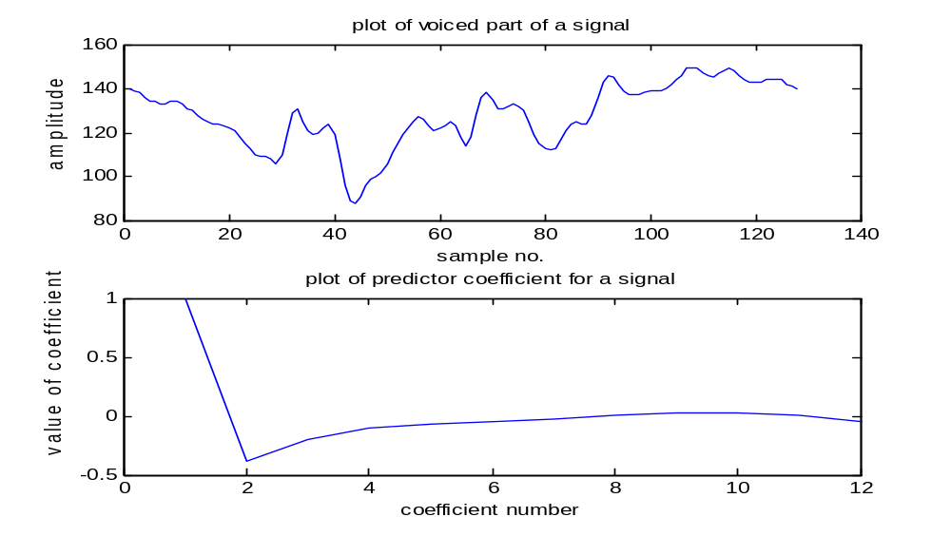 Figure 4.6 Plot of signal and its predictor coefficients
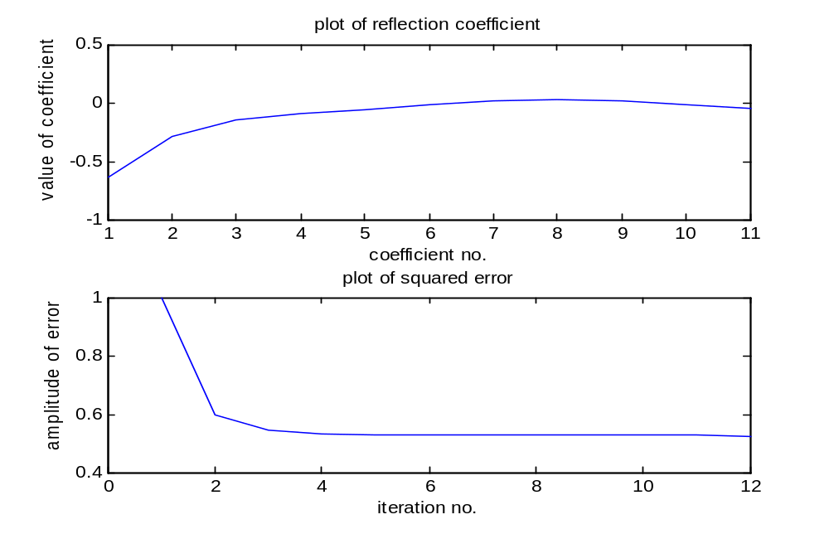
Figure 4.7 Plot of reflection coefficients and error
Program 2: A MATLAB program to find LPC using Burg algorithm is given below. Figure 4.7 shows a plot of 128 speech samples and 12 predictor coefficients and Figure 4.8 shows the plot of reflection coefficients. Note that the vale of reflection coefficient is always less than 1. Figure 4.9 shows a plot of signal and lpc coefficients. Figure 4.10 depicts the plot of reflection coefficients. We have normalized the LPCs by the first LPC.

%computes predictor coefficients using Burg algorithm
clear all;
fp=fopen('watermark.wav');
fseek(fp,224000,-1);
x=fread(fp,128);
subplot(2,1,1);plot(x);title('plot of voiced part of a signal');
xlabel('sample no.');ylabel('amplitude');
x=x-128;
y=lpc(x,12);
disp(y);
sum=0;
for i=1:128,
sum=sum+x(i)*x(i);%signal power
end
pe=sum;%predicion error
r(1)=sum/128;%autocorrelation
rc(1)=1;
mlpc(1, 1)=1;%prediction coefficients
for i=1:128,
pef(1, i)=x(i)/128;%compute initial prediction errors
per(1, i)=x(i)/128;

end
rc(1)=1;
mlpc(1,1)=1;

for i=2:128,
pef(2, i)=(pef(1, i) + 1 * per(1, i))/128;%compute initial prediction errors
per(2, i)=(per(1, i-1) + 1 * pef(1,i-1))/128;

end

%initialization of parameters ends
for k=2:12,%order of predictor selcted is 12.

mlpc(1,1)=1;
for i=k+1:127,
pef(k+1 , i)=(pef(k, i) + mlpc(k-1, k-1) * per(k, i))/128;%compute initial prediction errors
per(k+1 , i)=(per(k, i-1) + mlpc(k-1, k-1) * pef(k, i-1))/128;
end

sump = 0.0;
sumq = 0.0;
for i=k:128,
sump = sump + (pef(k + 1, i) * per(k + 1, i))/128;
sumq = sumq + ((pef(k + 1, i) * pef(k + 1, i) + per(k + 1, i) * per(k + 1, i)))/128;
end
akk=-2*sump/sumq;disp(akk);
rc(k)=akk;
mlpc(k,k)=akk;

if k > 1,
for i=1:k-1,
mlpc(k, i)=mlpc(k-1,i)+mlpc(k-1, k-i)*mlpc(k,k);
end
end

end
mm=max(mlpc);
disp(mlpc/-2.1031);
mlpc1=[ 1.0000 -0.7270 -0.0529 0.5977 -0.5883 0.3585 -0.1038 -0.0798 -0.0145 0.1957 -0.2436 0.1272];

subplot(2,1,2);plot(mlpc1);

title('plot of LPC using Burg algorithm');
xlabel('coefficient no.');ylabel('value of coefficient');
figure;disp(rc);
plot(rc);title('plot of reflection coefficients');
xlabel('coefficient no.');ylabel('value of coefficient');

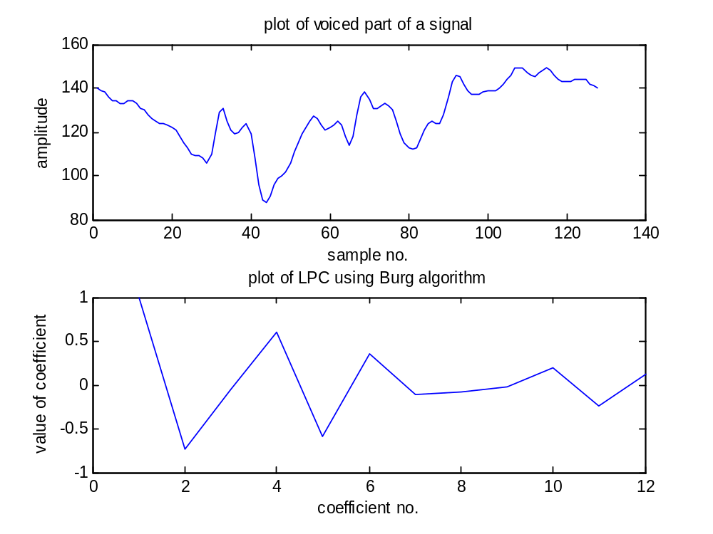

Figure 4.9 Plot of 128 speech samples and 12 predictor coefficients

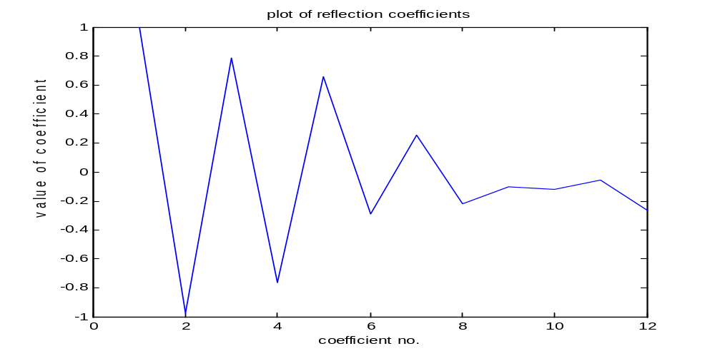
Figure 4.10 Plot of reflection coefficients

Program 3: Let us consider one example of 128 points of the speech signal from the speech wave file. We have plotted the signal in Figure 4.11. We can use a direct command in MATLAB called as ‘lpc’ to find LPC coefficients. We will use the procedure stated above to find LSFs for these evaluated LPC. We have given a MATLAB program to implement all these steps. Figure 4.11 shows a plot of signal with its LPC and Figure 4.12 shows the Z plane plot of LSFs. We can see that LSFs lie on the unit circle in Z plane. These are symmetrical with respect to the real Z axis.

%conversion of LPC to LSF

clear all;
fp=fopen('watermark.wav');
fseek(fp,224000,-1);
x=fread(fp,128);

subplot(2,1,1);plot(x);title('plot of voiced part of a signal');
xlabel('sample no.');ylabel('amplitude');

x=x-128;
y=lpc(x,12);

subplot(2,1,2);plot(y);title('plot of LPC for voiced signal');
xlabel('coefficient number');ylabel('Value of coefficient');

p = length(y)-1; % The leading one in the polynomial is not used
y = y(:);
y1 = [y;0];%append zero
disp(y1);
y2 = y1(end:-1:1);%invert the coefficients
disp(y2);
P1 = y1-y2; % Difference filter is formed

disp(P1);
Q1 = y1+y2;
disp(Q1);% Sum Filter is formed

% If order is even, remove the known root at z = 1 for P1 and z = -1 for Q1 If odd, remove both the roots from P1

if rem(p,2), % Odd order
P = deconv(P1,[1 0 -1]);
Q = Q1;
else % Even order
P = deconv(P1,[1 -1]);%finds division polynomial
Q = deconv(Q1,[1 1]);
end

rP = roots(P);
rQ = roots(Q);

aP = angle(rP(1:2:end));%finds the angle of the root
aQ = angle(rQ(1:2:end));

linepair = sort([aP;aQ]);
disp(linepair);
z=exp(j*linepair);%finds complex z zeros using the angle
disp(z);
z = [z;conj(z)];%include conjugate zeros
figure;
zplane(z);title('plot of zeros in z plane');
xlable('real z');ylabel('imag z');

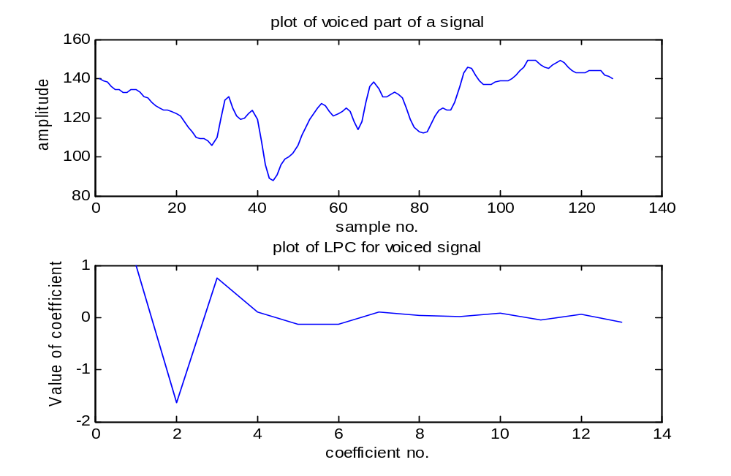
Figure 4.11 Plot of a signal and its LPC
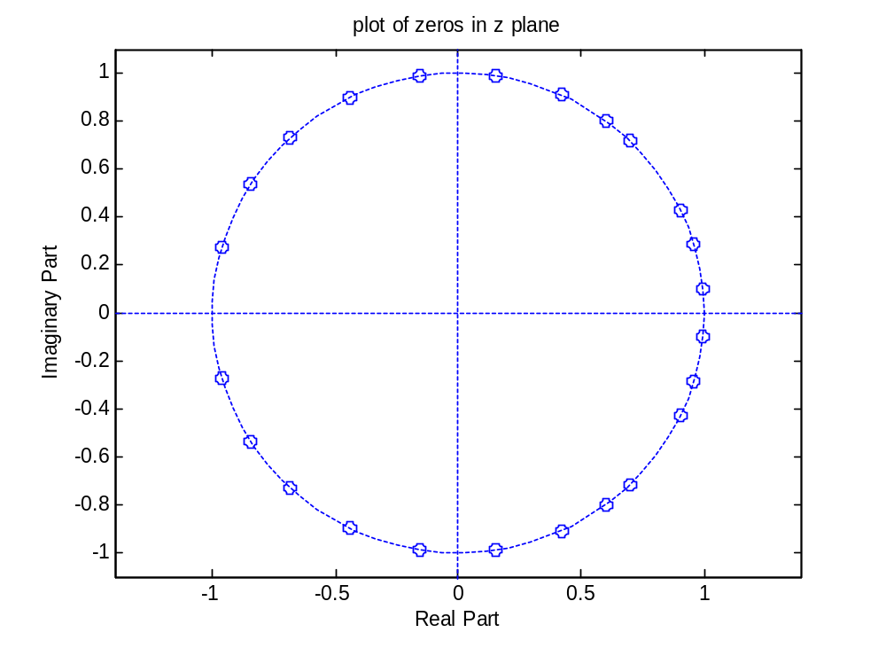
Figure 4.12 Z plane plot of LSFs.

Program 4: We will now consider the 128 samples of the other speech signal. Find and plot the LPC and convert these LPC to LSFs using the same procedure used in the last example. A MATLAB program is slightly modified to get 128 speech samples for speech file testSignal.wav. Figure 4.13 shows plot of signal and its LPC and Figure 4.14 shows the Z plane plot of LSFs.

%conversion of LPC to LSF

clear all;
fp=fopen('testSignal.wav','r');
fseek(fp,110000,-1);
x=fread(fp,'int',128);

subplot(2,1,1);plot(x);title('plot of voiced part of a signal');
xlabel('sample no.');ylabel('amplitude');

x=x-128;
y=lpc(x,12);

subplot(2,1,2);plot(y);title('plot of LPC for voiced signal');
xlabel('coefficient number');ylabel('Value of coefficient');

p = length(y)-1; % The leading one in the polynomial is not used
y = y(:);
y1 = [y;0];%append zero
disp(y1);
y2 = y1(end:-1:1);%invert the coefficients
disp(y2);
P1 = y1-y2; % Difference filter is formed

disp(P1);
Q1 = y1+y2;
disp(Q1);% Sum Filter is formed

% If order is even, remove the known root at z = 1 for P1 and z = -1 for Q1 If odd, remove both the roots from P1

if rem(p,2), % Odd order
P = deconv(P1,[1 0 -1]);
Q = Q1;
else % Even order
P = deconv(P1,[1 -1]);%finds division polynomial
Q = deconv(Q1,[1 1]);
end

rP = roots(P);
rQ = roots(Q);

aP = angle(rP(1:2:end));%finds the angle of the root
aQ = angle(rQ(1:2:end));

linepair = sort([aP;aQ]);
disp(linepair);
z=exp(j*linepair);%finds complex z zeros using the angle
disp(z);
z = [z;conj(z)];%include conjugate zeros
figure;
zplane(z);title('plot of zeros in z plane');
xlable('real z');ylabel('imag z');

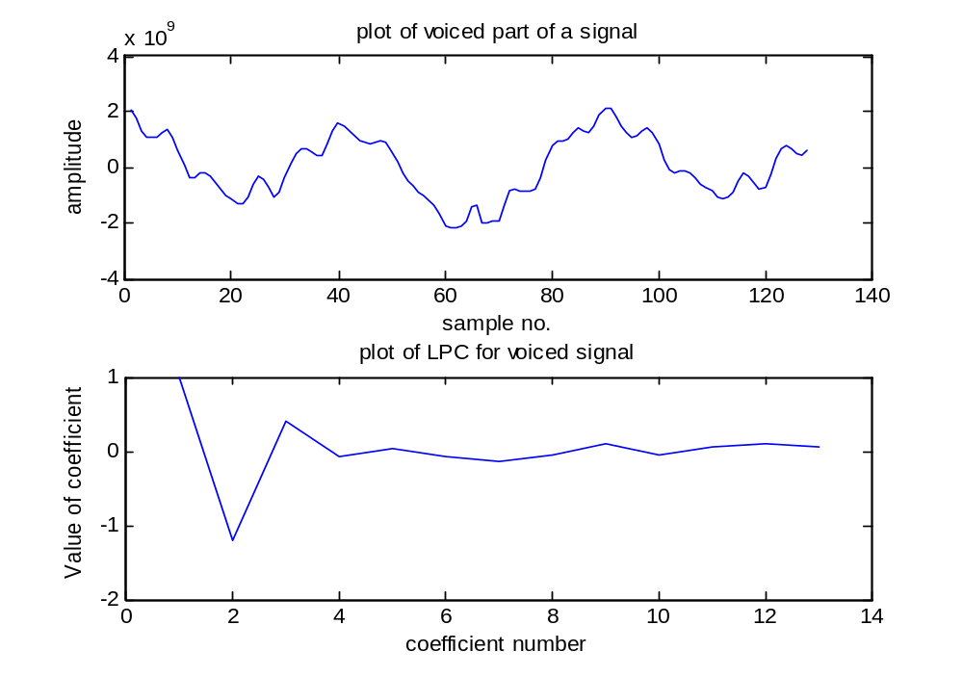
Figure 4.13 plot of signal and its LPC
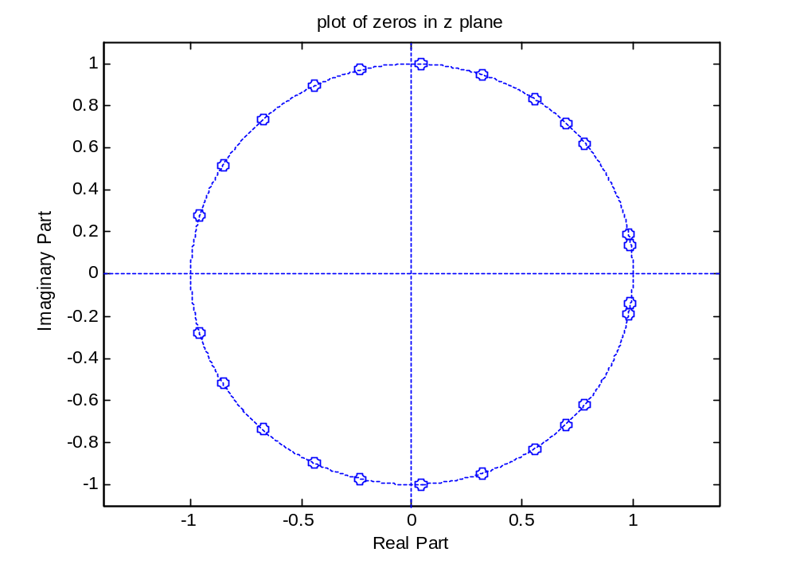
Figure 4.14 Z plane plot of LSFs

Program 5: We will now track unvoiced segment of the speech file and find LPC and corresponding LSFs. Figure 4.15 shows plot of 128 speech sample those are unvoiced and it LPC and Figure 4.16 shows Z plane plot of LSFs. Only following lines are modified in MATLAB program as shown below. Note the changes in LSF locations.

clear all;
fp=fopen('testSignal.wav','r');
fseek(fp,122000,-1); % offset is changed
x=fread(fp,128,'int');

subplot(2,1,1);plot(x);title('plot of unvoiced part of a signal');%change in title.
xlabel('sample no.');ylabel('amplitude');

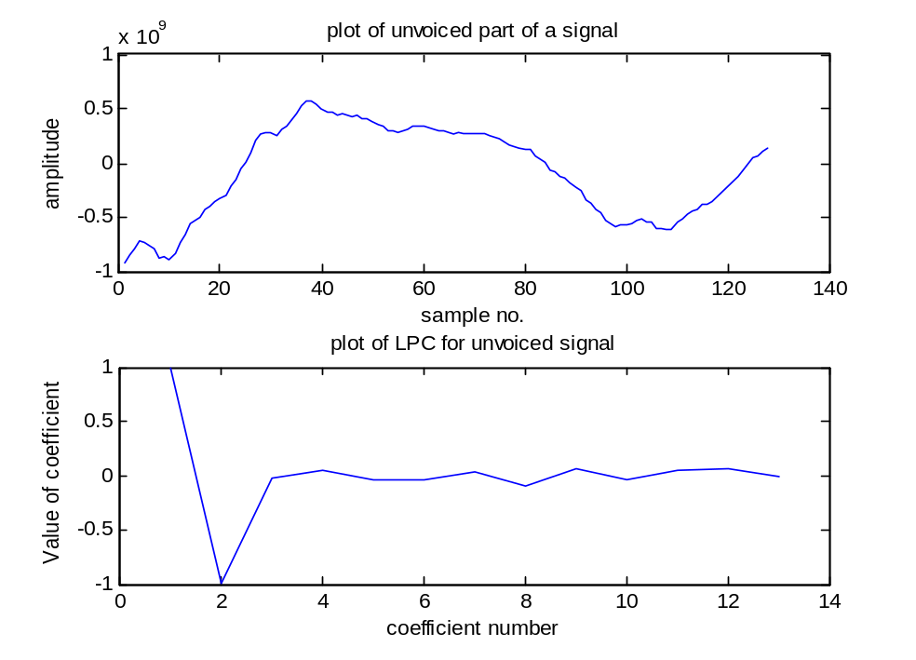
Figure 4.15 Plot of unvoiced signal and its LPC
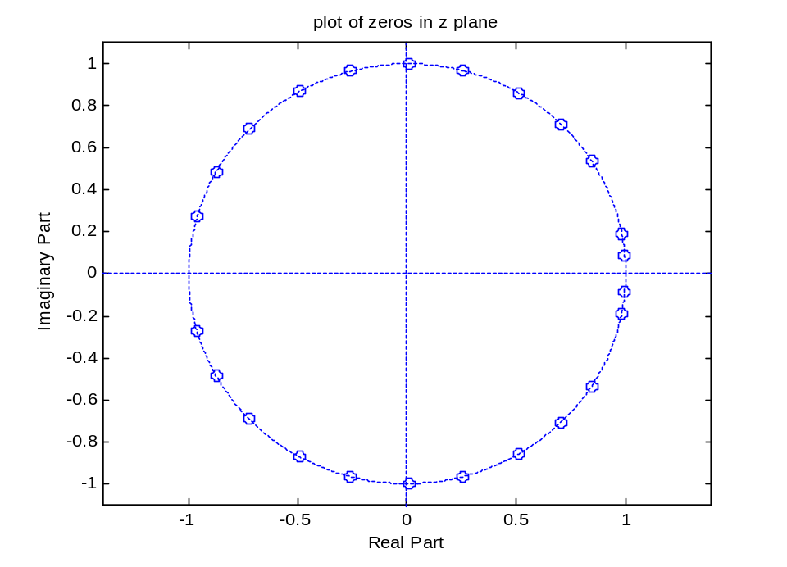
Figure 4.16 Z plane Plot of LSFs for unvoiced signal

Program 6: We will convert LSFs obtained in example 1 to LPC again. A MATLAB program to convert LSFs to LPC is given below. The LSFs plotted in Figure 4.12 are given as input to the program. Figure 4.17 depicts the plot of LPC. We can confirm that we got the same values of LPC. Compare the plot with Figure 4.11.

%program to convert LSF to LPC
clear all;
%we have used lsf obtained in earlier example as input to this program.
lsf=[0.1011 0.2889 0.4432 0.7964 0.9231 1.1360 1.4195 1.7290 2.0260 2.3238 2.5755 2.8627 ];
lsf = lsf(:);
p = length(lsf); % finds the model order

% we will now convert the angle to the zeros (amplitude is unity
z = exp(j*lsf);
z1 = [z;conj(z)];%include conjugate zeros
figure;
zplane(z1);title('plot of zeros in z plane');
xlabel('real z');ylabel('imag z');
rQ = z(1:2:end);% Separate the zeros belonging to sum and difference polynomial
% take zeros alternately
rP = z(2:2:end);

rQ = [rQ;conj(rQ)];% Include the conjugate zeros
rP = [rP;conj(rP)];

% Form the polynomials using zeros above
Q = poly(rQ);
P = poly(rP);

% Form the sum and difference filters by including known roots at z = 1 and
% z = -1

if rem(p,2),
% Odd order: z = +1 and z = -1 are roots of the difference filter, P1(z)
P1 = conv(P,[1 0 -1]);
Q1 = Q;
else
% Even order: z = -1 is a root of the sum filter, Q1(z) and z = 1 is a
% root of the difference filter, P1(z)
P1 = conv(P,[1 -1]);
Q1 = conv(Q,[1 1]);
end

% Prediction polynomial is formed by averaging P1 and Q1

y = .5*(P1+Q1);
disp(y);
figure;
plot(y);title('plot of LPC');
xlabel('coefficient number');ylabel('Value of coefficient');

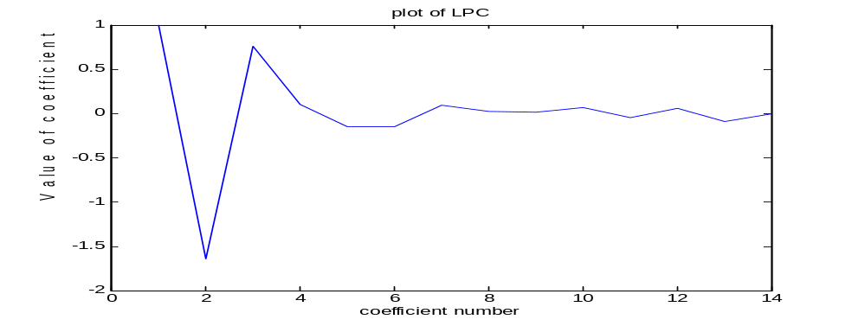
Figure 4.17 Plot of LPC.

